SCHOOL OF COMPUTER SCIENCE AND ARTIFICIAL INTELLIGENCE |  |  |  |  | DEPARTMENT OF COMPUTER SCIENCE ENGINEERING
ProgramName:B. Tech |  |  |  | Assignment Type: Lab |  |  | AcademicYear:2025-2026
CourseCoordinatorName |  |  |  | Venkataramana Veeramsetty
Instructor(s)Name |  |  |  | Dr. V. Venkataramana (Co-ordinator)  Dr. T. Sampath Kumar  Dr. Pramoda Patro  Dr. Brij Kishor Tiwari  Dr.J.Ravichander  Dr. Mohammand Ali Shaik  Dr. Anirodh Kumar  Mr. S.Naresh Kumar  Dr. RAJESH VELPULA  Mr. Kundhan Kumar  Ms. Ch.Rajitha  Mr. M Prakash  Mr. B.Raju  Intern 1 (Dharma teja)  Intern 2 (Sai Prasad)  Intern 3 (Sowmya)  NS_2 ( Mounika)
CourseCode |  |  | 24CS002PC215 | CourseTitle |  | AI Assisted Coding
Year/Sem |  |  | II/I | Regulation |  | R24
Date and Day  of Assignment |  |  | Week1 - Tuesday | Time(s)
Duration |  |  | 2 Hours | Applicableto  Batches |  | 24CSBTB01 To 24CSBTB39
AssignmentNumber:1.2(Present assignment number)/24(Total number of assignments)
 | Q.No. | Question |  |  |  |  |  | ExpectedTime  to complete
 | 1 | Lab 1: Environment Setup – GitHub Copilot and VS Code Integration  Lab Objectives:  - To install and configure GitHub Copilot in Visual Studio Code.  - To explore AI-assisted code generation using GitHub Copilot.  - To analyze the accuracy and effectiveness of Copilot's code suggestions.  - To understand prompt-based programming using comments and code context  Lab Outcomes (LOs):  After completing this lab, students will be able to:  - Set up GitHub Copilot in VS Code successfully.  - Use inline comments and context to generate code with Copilot.  - Evaluate AI-generated code for correctness and readability.  - Compare code suggestions based on different prompts and programming styles.  Task Description#1  - Write a comment: # Function to check if a string is a valid palindrome (ignoring spaces and case) and allow Copilot to complete it.  Expected Output#1  - A function that correctly returns True for phrases like "A man a plan a canal Panama"  Prompt: write a function in python that takes input from user to check if a string is a palindrome ignoring spaces and case.  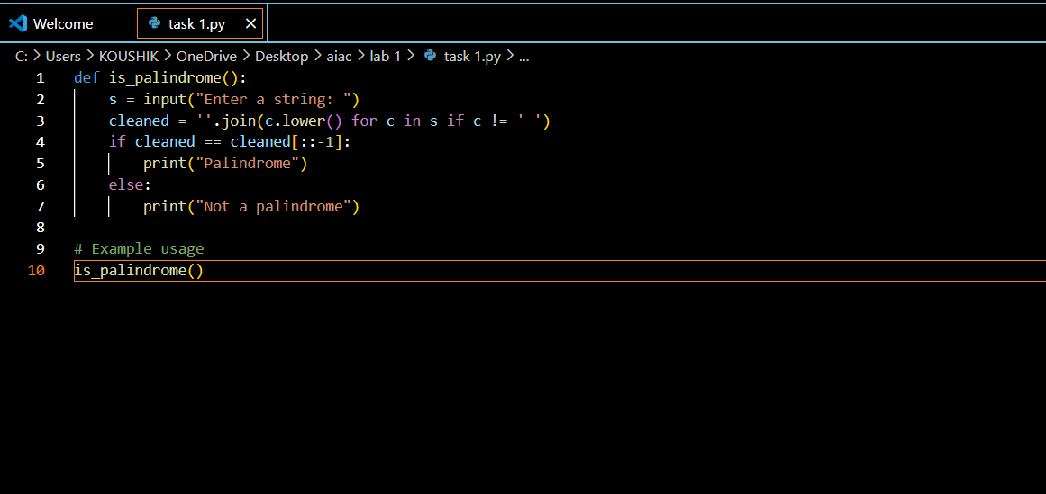  Output:  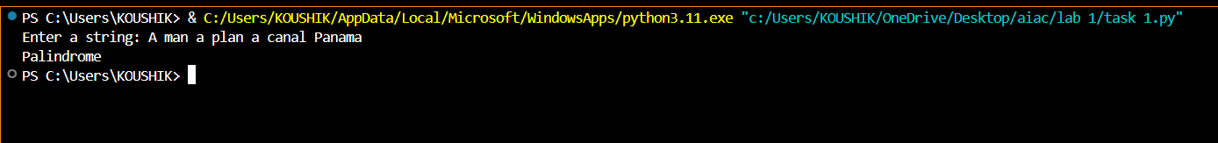  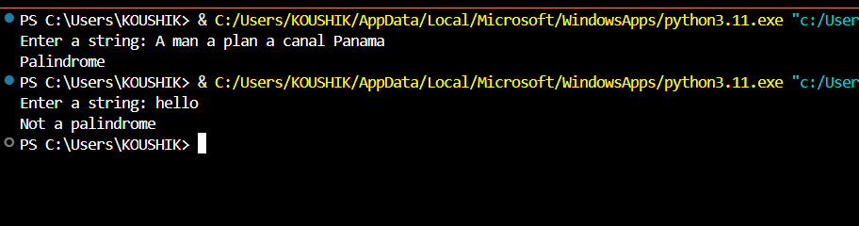  Task Description#2  - Generate a Python function that returns the Fibonacci sequence up to n terms. Prompt with only a function header and docstring  Expected Output#2  - AI completes the function logic using loop or recursion with accurate output  Prompt: write a Python function that returns the Fibonacci sequence up to n terms  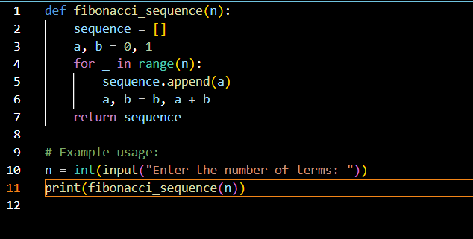  Output:  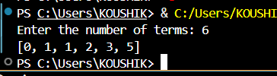  Task Description#3  - Write a comment like # Function to reverse a string and use Copilot to generate the function.  Expected Output#3  - Auto-completed reverse function  Prompt: genarate the function that can take an input string and reverse it and print it and call the function  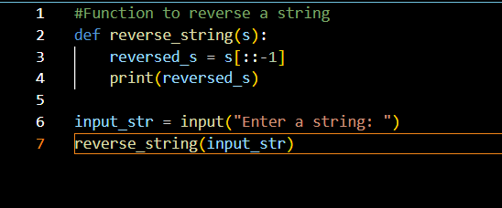  Output:  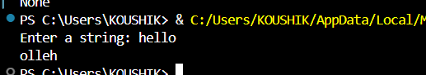  Task Description#4  - Generate a program that simulates a basic calculator (add, subtract, multiply, divide). Write the comment: # Simple calculator with 4 operations and let AI complete it.  Expected Output#4  - Fully working calculator with input/output and operator selection logic  Prompt: Generate a program that simulates a basic calculator that can add, subtract, multiply, divide any 2 numbers  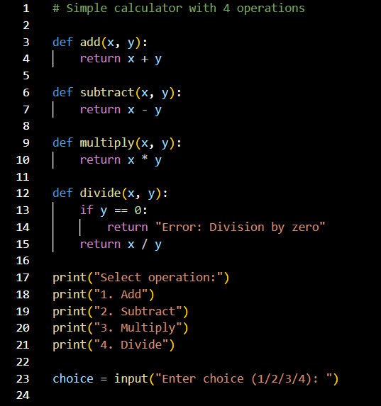  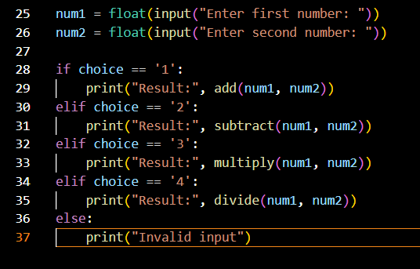  Output:  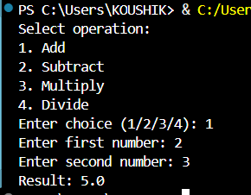  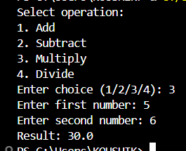  Task Description#5  - Use a comment to instruct AI to write a function that reads a file and returns the number of lines..  Expected Output#5  - Functional implementation using open() or with open() and readlines()  Prompt: write an python code to open an file and read a file and return the number of lines and return the output and print it  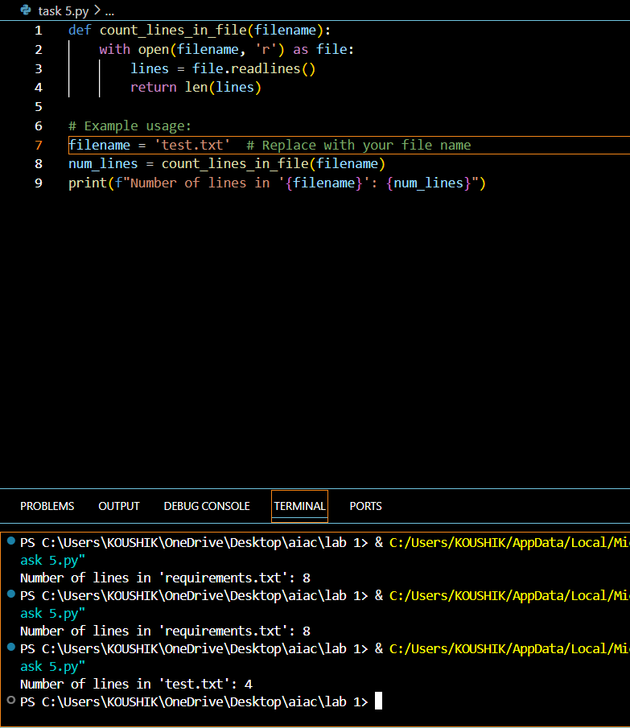  Note: Report should be submitted a word document for all tasks in a single document with prompts, comments & code explanation, and output and if required, screenshots  Evaluation Criteria:  Criteria Max Marks  Task #1 0.5  Task #2 0.5  Task #3 0.5  Task #4 0.5  Task #5 0.5  Total 2.5 Marks |  |  |  |  |  | Week1 - wednesday

